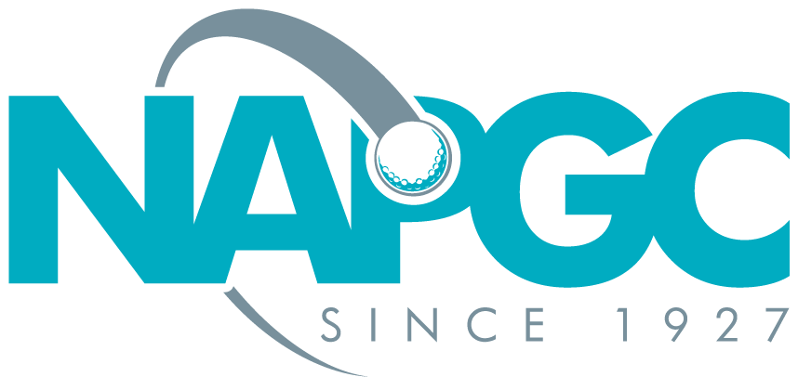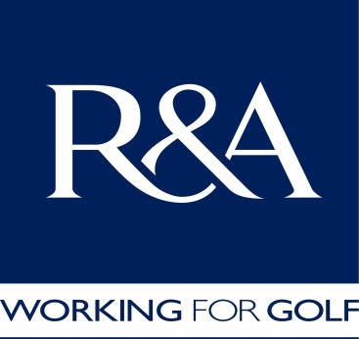
Mary Forster Bowl 2023/2024
Winter Round Robin competition for teams of Three Lady Players,
Stableford Format,
Final Venue TBA Sunday 28th April 2024
Golf Club ……………………………………………. Team Name …………………………………….
Club Contact Detail: First Name: …………………..….. Last name ………………………………..
Home Phone: ……………………………...………Mobile Phone: …………………………………….
email

Entry Fee £20.00 per team
We have read the conditions of the Competition and confirm that
we comply with them in all respects and the information supplied is correct

Number of Teams……………………….. Total Amount at £20.00 per team £ ……….………..
Signature of Club Official: ………………………………………………………. Date: ………………

Closing date for entries 12th Nov 2023

(Rules and consent forms can be found at www.napgc.org.uk )
This form together with the entry fee of £20.00 per team should be sent to:
Les Hasell, Competition Organiser
6 Chepstow Close, Pound Hill, Crawley, Sussex RG10 7XF
Telephone: 01293 884537, Mobile: 07788 518183
Les.Hasell@napgc.org.uk

If you wish to pay by BACS please use the following information:
Bank Barclays Bank PLC, Whetstone Branch
Account National Association of Public Golf Courses
A/c Number 60663042 Sort Code 20 - 95 - 61
Reference GF and club name
Please advise when a BACS payment has been made

